**Creating a table:**

create table student1(

std_id int,

std_name varchar(20)

);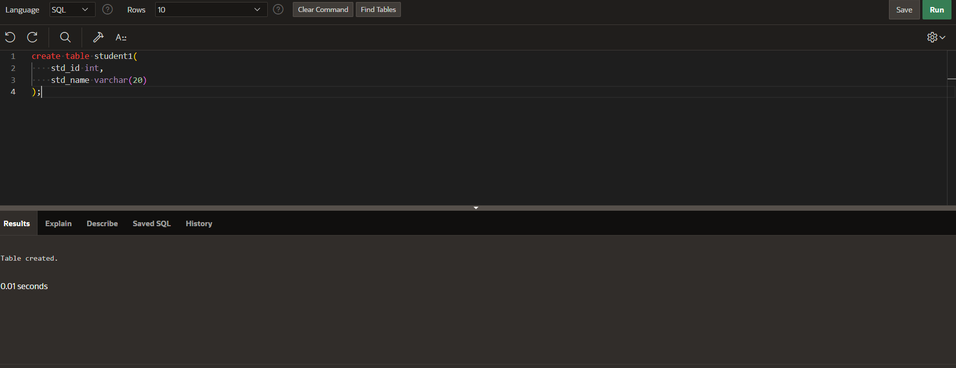

**Modifying table:**

alter table student1 add marks int;

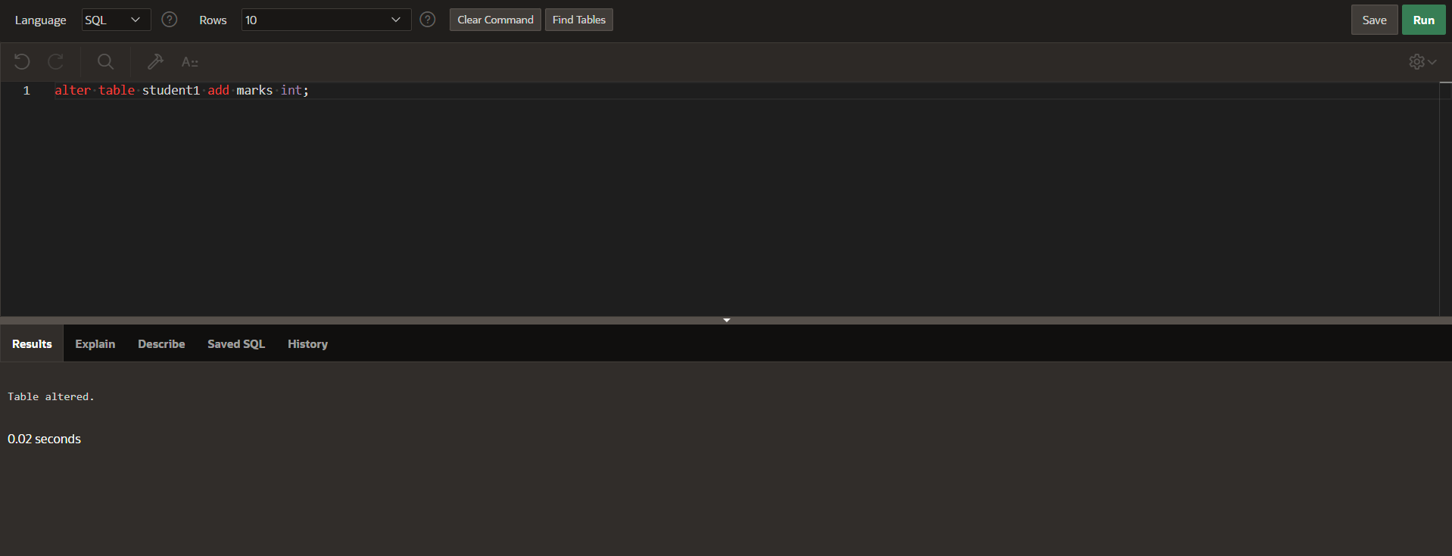

**Describing table:**

desc student1;

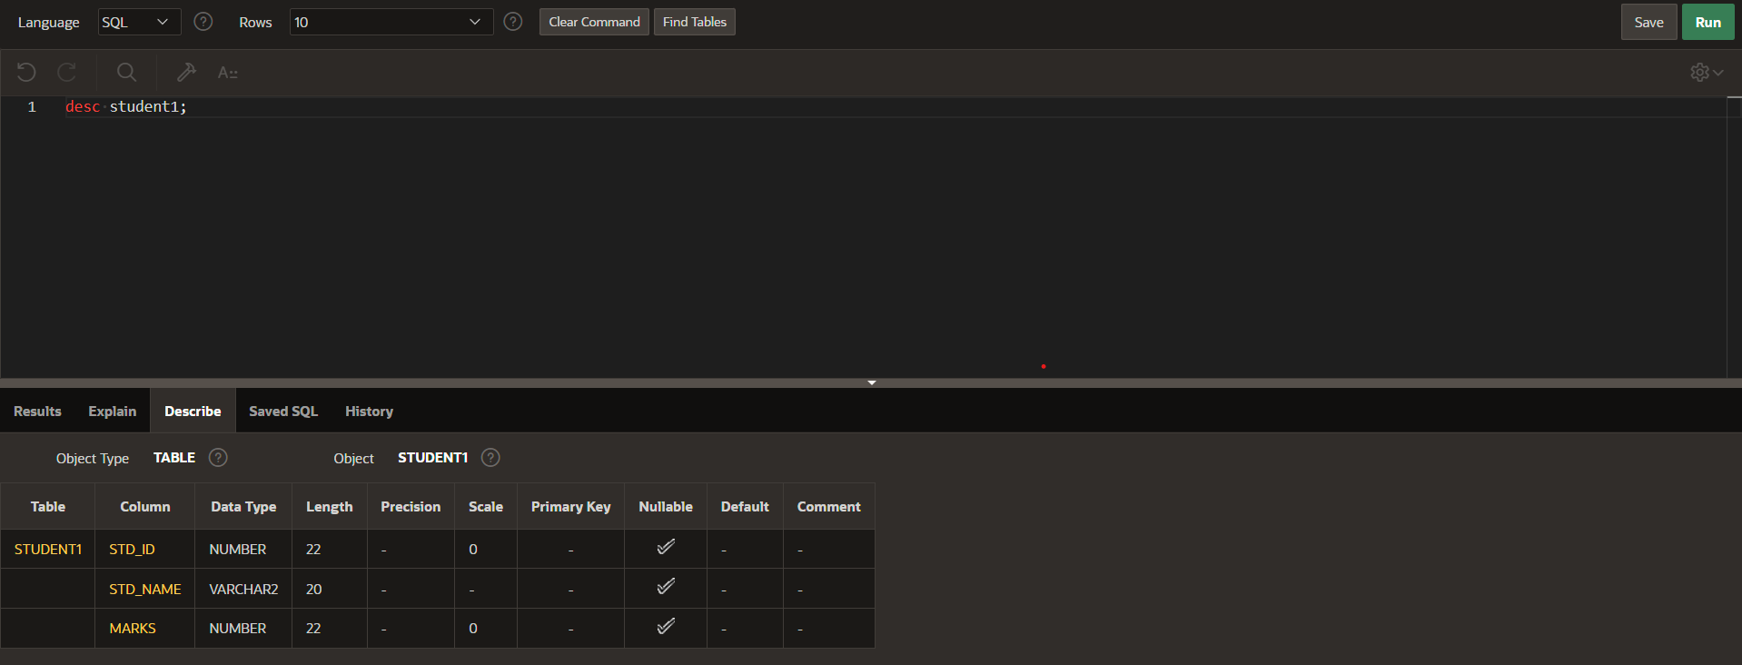

**Inserting values into table:**

insert into student1

values(1920,'rupesh',90);

insert into student1

values(1921,’uday',85);

insert into student1

values(1922,’harshit’,87);

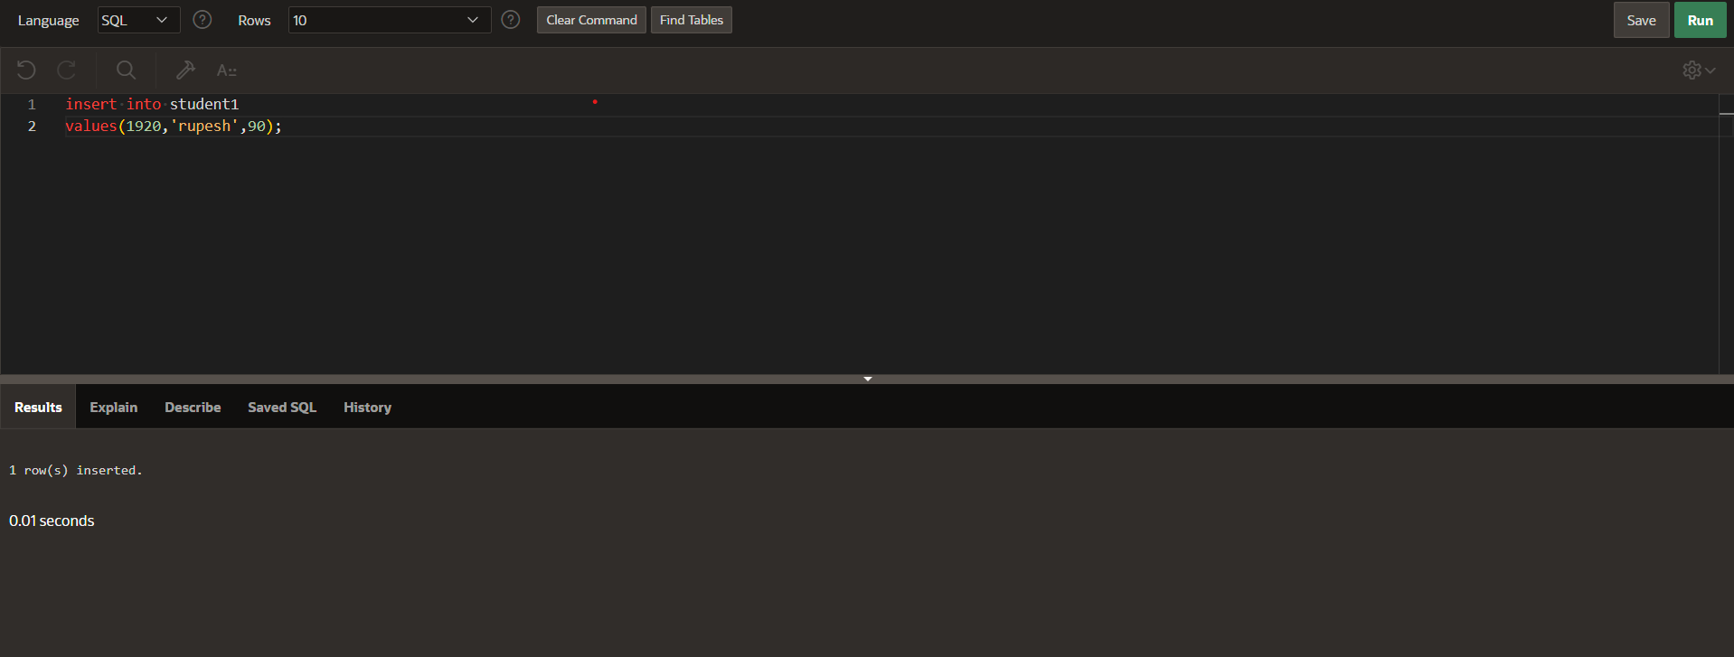

**Updating the values in table;**

update student1

set marks=89

where std_id=1922;

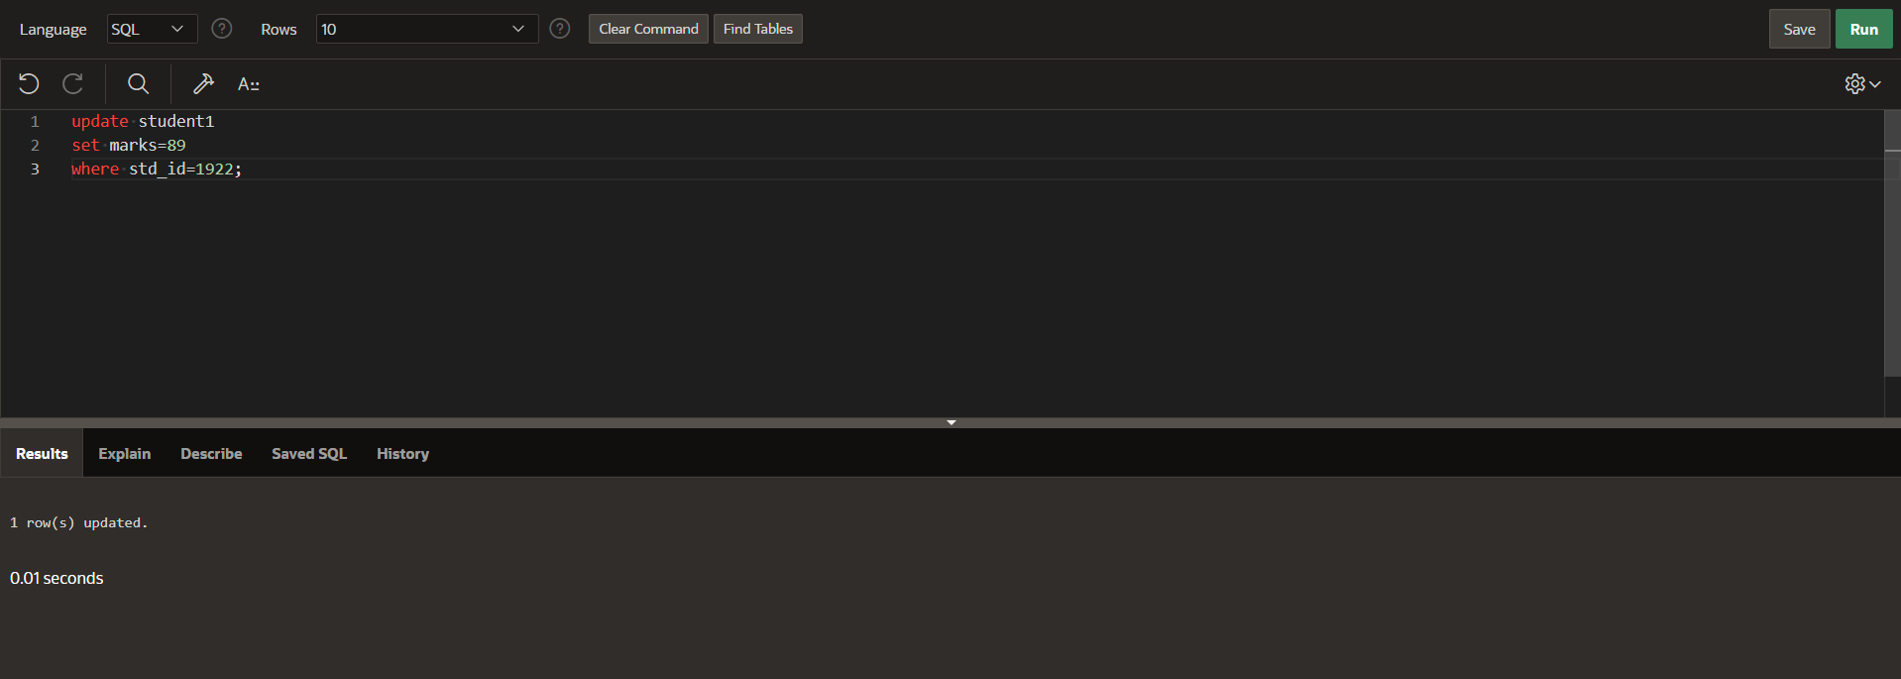

**Displaying the table with data:**

select *from student1;

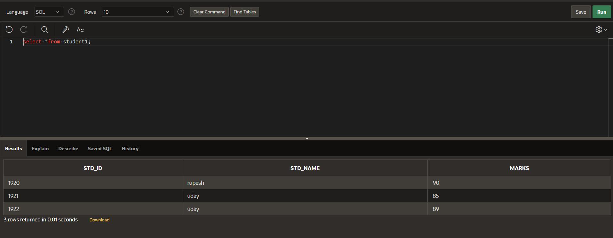

**Displaying the table In order of marks:**

select *from student1

order by marks;

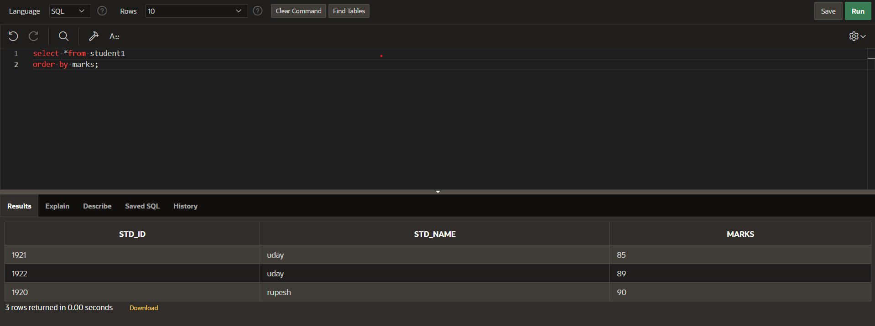

**displaying minimum marks form table**:

select min(marks)

from student1;



**displaying maximum marks form table:**

select max(marks)

from student1;

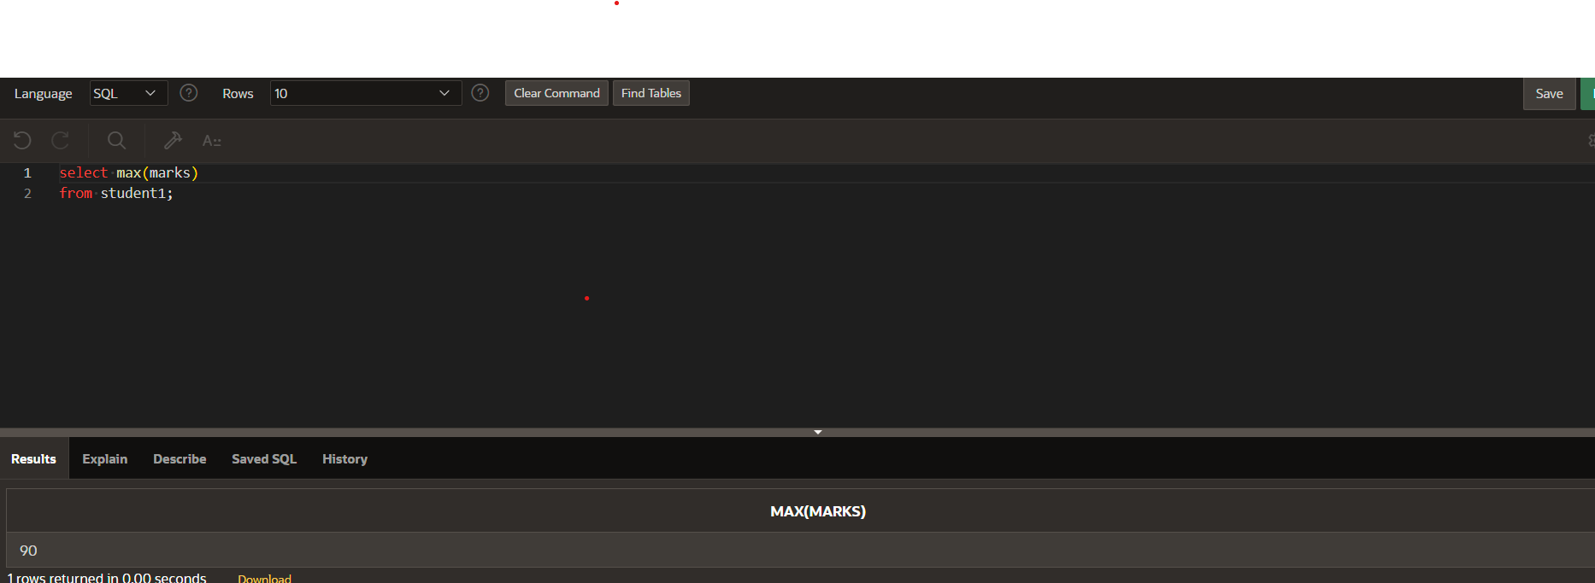

**Displaying the sum of all marks:**

select sum(marks)

from student1;

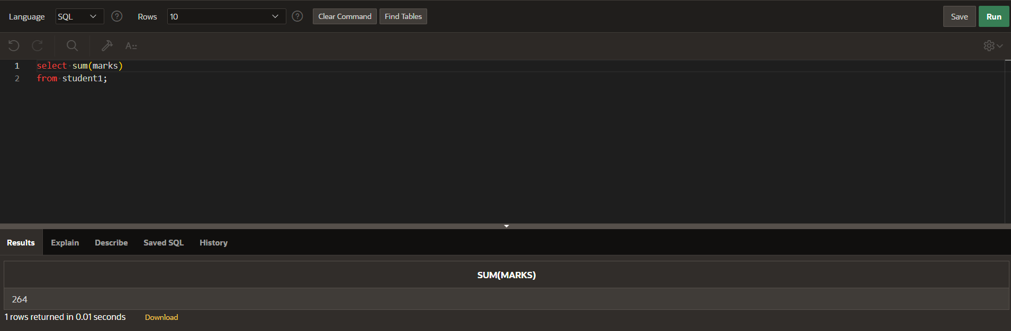

**Displaying average of marks:**

select avg(marks)

from student1;

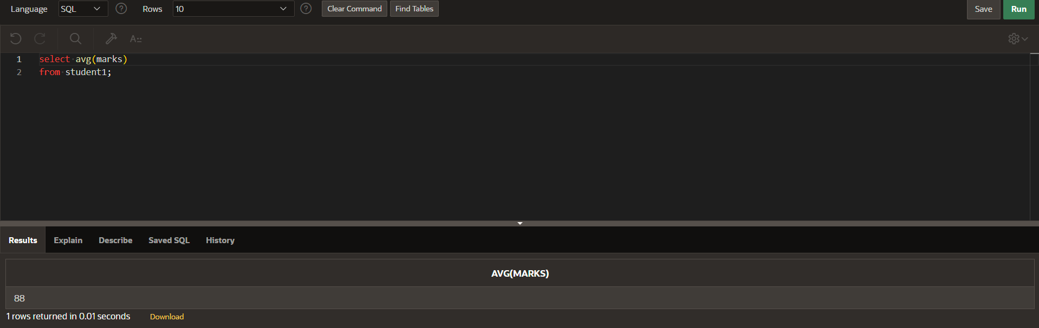

**Counting number of students:**

select count(*)

from student1; 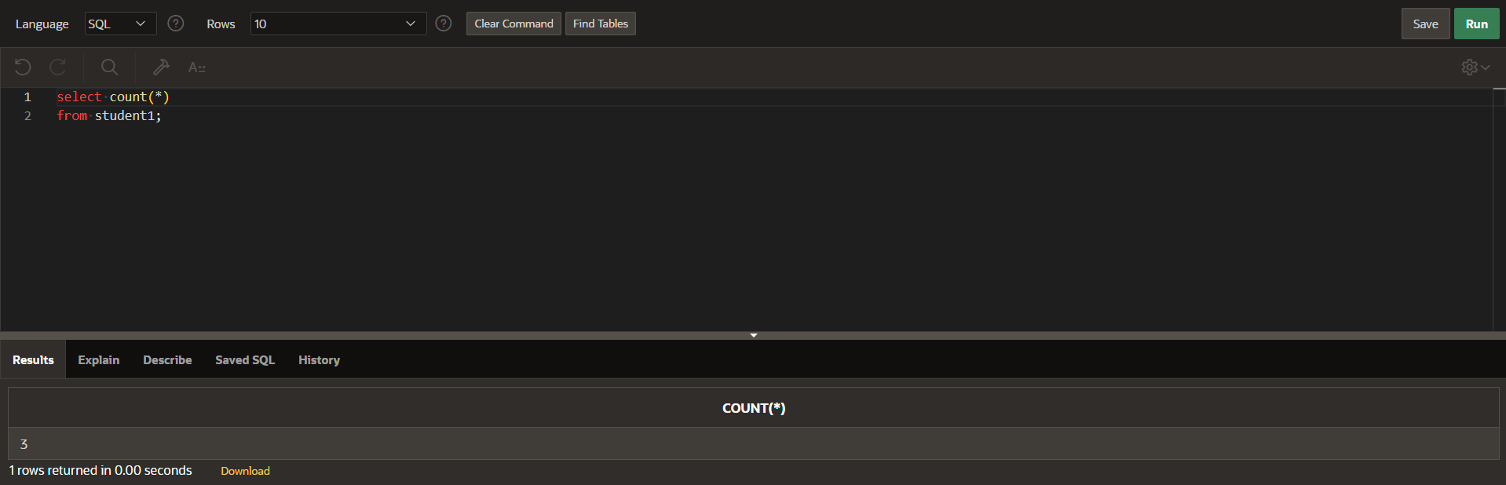

**deleting a row:**

delete from student1

where std_id=1922; 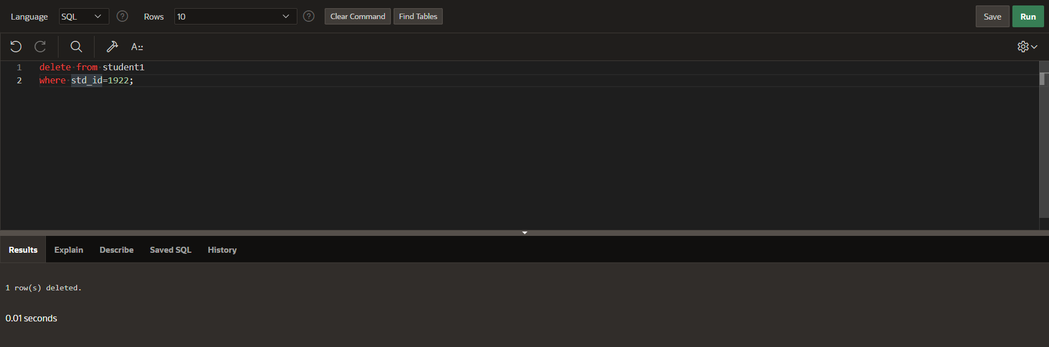

**truncate the table:**

truncate table student1;

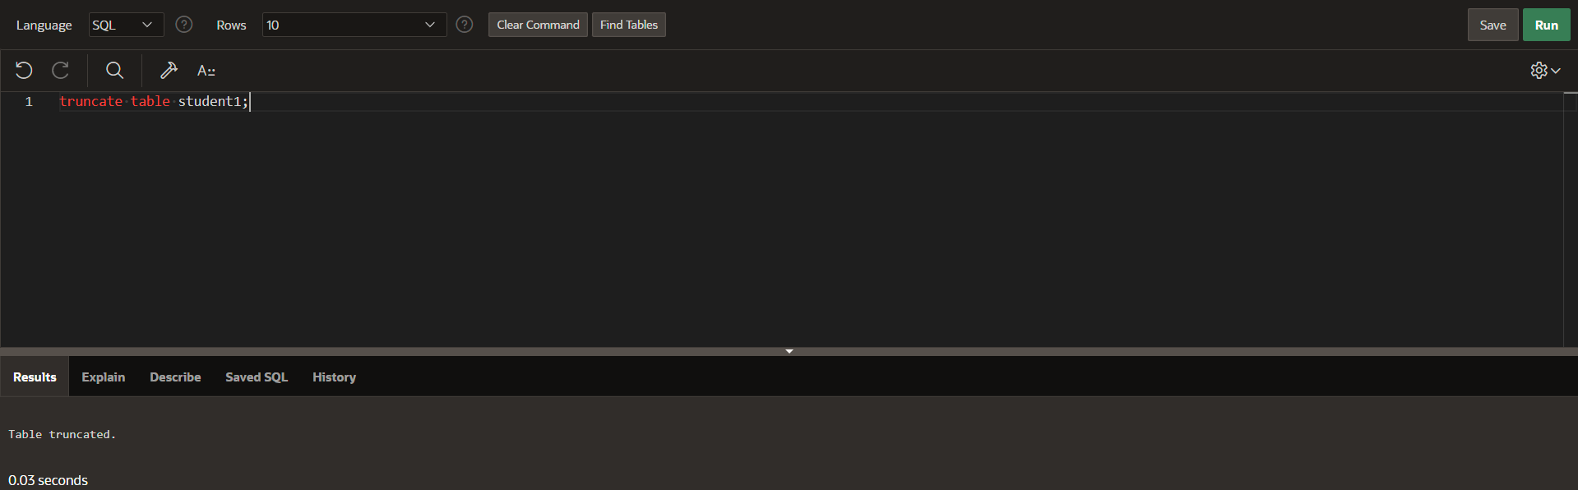

**Drop the table:**

drop table student1;

